Key Points Summary
Learning online is new for pupils, parents and many teachers. This document provides advice on how to setup for learning, to be part of online meetings and access learning in Microsoft Teams. The key points are:

For pupils:

- find a quiet space
- use headphones if you can
- place your device so the camera does not show too much of your home (to protect your privacy). Consider making use of appropriate customised backgrounds.
- behave in the lesson as you would be expected to in school
- be kind and considerate of others
- follow up tasks will be in Microsoft Teams – you can ask questions of your teacher there

For parents:

- Help your child find the best place to work (if possible, not a bedroom, consider making use of customised backgrounds)
- Be on hand, if you can, to help if needed
- Take an interest in your child’s work and the work left for him/her to complete in Microsoft Teams
- The Teams Meeting is available for the delivery of learning and teaching. It is not a means of communication between parents and school. Parents should use normal communications channels as set up by the school

For staff:

- Continue to observe the highest professional standards
- Choose the method of delivery based on the lesson itself
- When using Microsoft Teams Meetings (Video Conferencing), place your device so the camera doesn’t show too much of your home (to protect your privacy). Consider making use of the customised backgrounds feature. For pupils who are hearing impaired, a blurred background will be most effective for lip-reading.
- Consider how to structure learning so that pupils can work effectively and make progress.

Microsoft Teams Meeting (Video Conferencing) - Live Lessons from your home

Pupils - Getting set up

First of all, if you are not comfortable with being on camera to speak with your teacher, let him or her know using an email, so that other arrangements can be put in place.

Using a Microsoft Teams Meeting is like inviting someone into your home. You need to think carefully about the view from your web camera and how you are set up at home for learning online. Here are some top tips.

1. Be dressed suitably - no PJs - get dressed as you would be happy to be seen outside of your home.
2. Sit somewhere with your back towards the wall. This will reduce how much of your home is in the camera frame. Consider making use of appropriate customised backgrounds.
3. Turn the TV and other distractions off. Try to find a space which is quiet. Don’t worry - we know this might not always be easy for everyone to do.
4. If you have some headphones, use them. You might need to change the meeting settings after you plug-in your headphones. This will work even better if they have a microphone. HELP HERE
5. Choose somewhere with good light but don’t have your back towards a window if you can avoid it. Too much light can make it difficult for others to see you on your camera.
6. Have your device on a table rather than on your knees. If you don’t have a table, use cushions under your device to make yourself more comfortable.
7. Have some paper/jotters handy with a pen or pencil so you can write notes if you need to. You could also use Microsoft OneNote or O365 Word to write short notes with your device during your meeting.

Pupils: Connecting to Your Meeting Your teacher will set a time for your meeting / lesson in Microsoft Teams. This is also where you will find the link for the meeting when it starts. Your teacher will be the first person in the meeting room and will be the last person to leave it. You may have to wait to be admitted to the meeting / lesson.

Top Tips for your meeting

1. Visit your Microsoft Team to get the meeting link just before the meeting is due to start.
2. You will not be able to join before your teacher.
3. Mute your microphone before you enter the meeting. You can also switch off your camera if you wish.

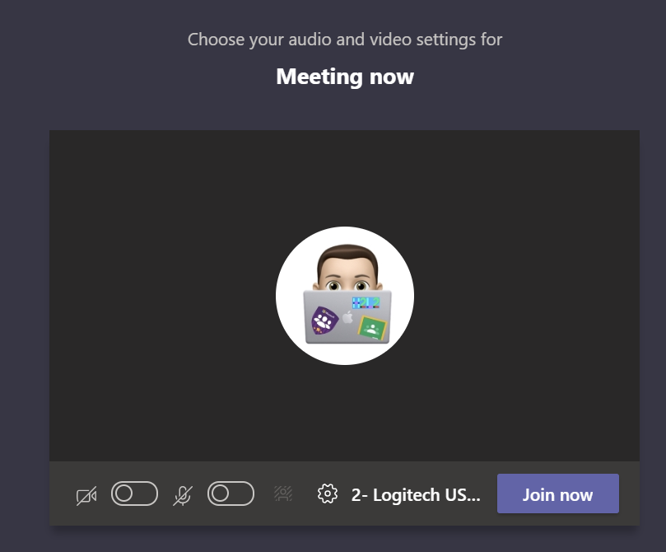

4. Click Join now to enter the Teams Meeting.
5. Once connected, listen carefully to your teacher. You can use the chat to ask questions or unmute your microphone and ask your question. You should mute your mic again after you have asked your questions.
6. In your Teams Meeting, be kind and considerate of other people. The Teams Meeting is just like being in school and you need to behave appropriately. Your teacher may remove you from the meeting if you do not do so. If you are removed from a meeting, the headteacher or another member of senior staff may discuss this with you and your parents/carers. Please remember, you have signed the Pupil Expectations Agreement.

7. When the call is complete, disconnect by clicking the red “hang up” button.

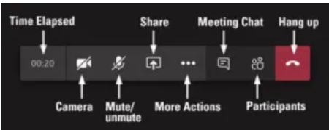

Remember to check your Microsoft Team after the meeting for any assignments that your teacher may have set for you.

Parents - Helping your child to set up & connect

Our tips for helping your child to be part of an online video lesson.

1. Remind your child that they need to behave appropriately in online lessons. Encourage them to be polite and respectful during the call. Be aware that inappropriate behaviour may result in your child being removed from the meeting and a follow-up discussion with school staff. Pupil Expectations Agreement.
2. Position the computer/device in a room where you can monitor their activity, preferably not a bedroom or consider making use of appropriate customised backgrounds.
3. Keep the background clear, with good lighting and sound (see our pupil tips above).
4. Information about who is hosting the lessons, what the lesson will be about and what tasks are set following it will all be shared in your child’s Microsoft Team. The link to the meeting will be shared in your child’s Microsoft Team just before the meeting is due to start.
5. Your child may need support in setting up the Microsoft Team Meeting, connecting their headphones, if they have them, and selecting the camera.

Audio and video settings can be adjusted by –
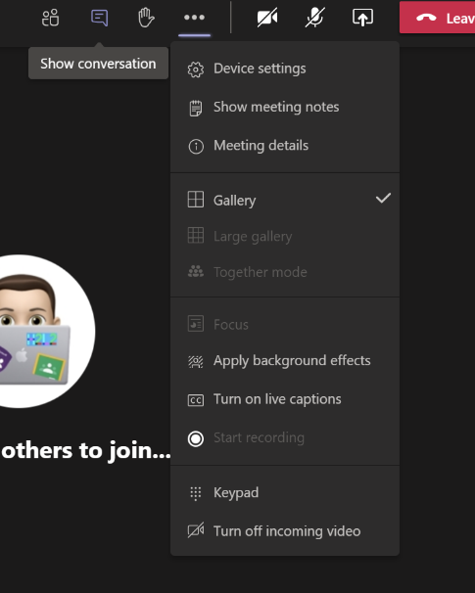

Clicking on the three dots (…) and select Device settings

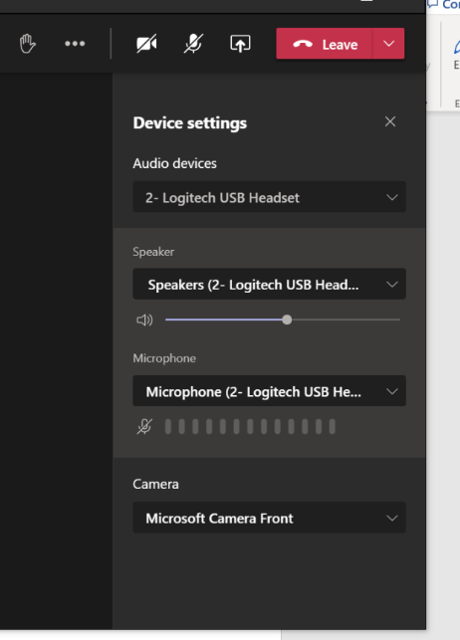

From this screen you can select and adjust Audio and Video controls

Help your child to do this and check the preview of the webcam before your child joins the meeting, and if required set a background image. (click the three dots (…) and select Show Background Effects. You can then preview the effect and when ready choose Apply. The video is not shared until you press Apply. You can also join the meeting with the camera OFF if you prefer this.

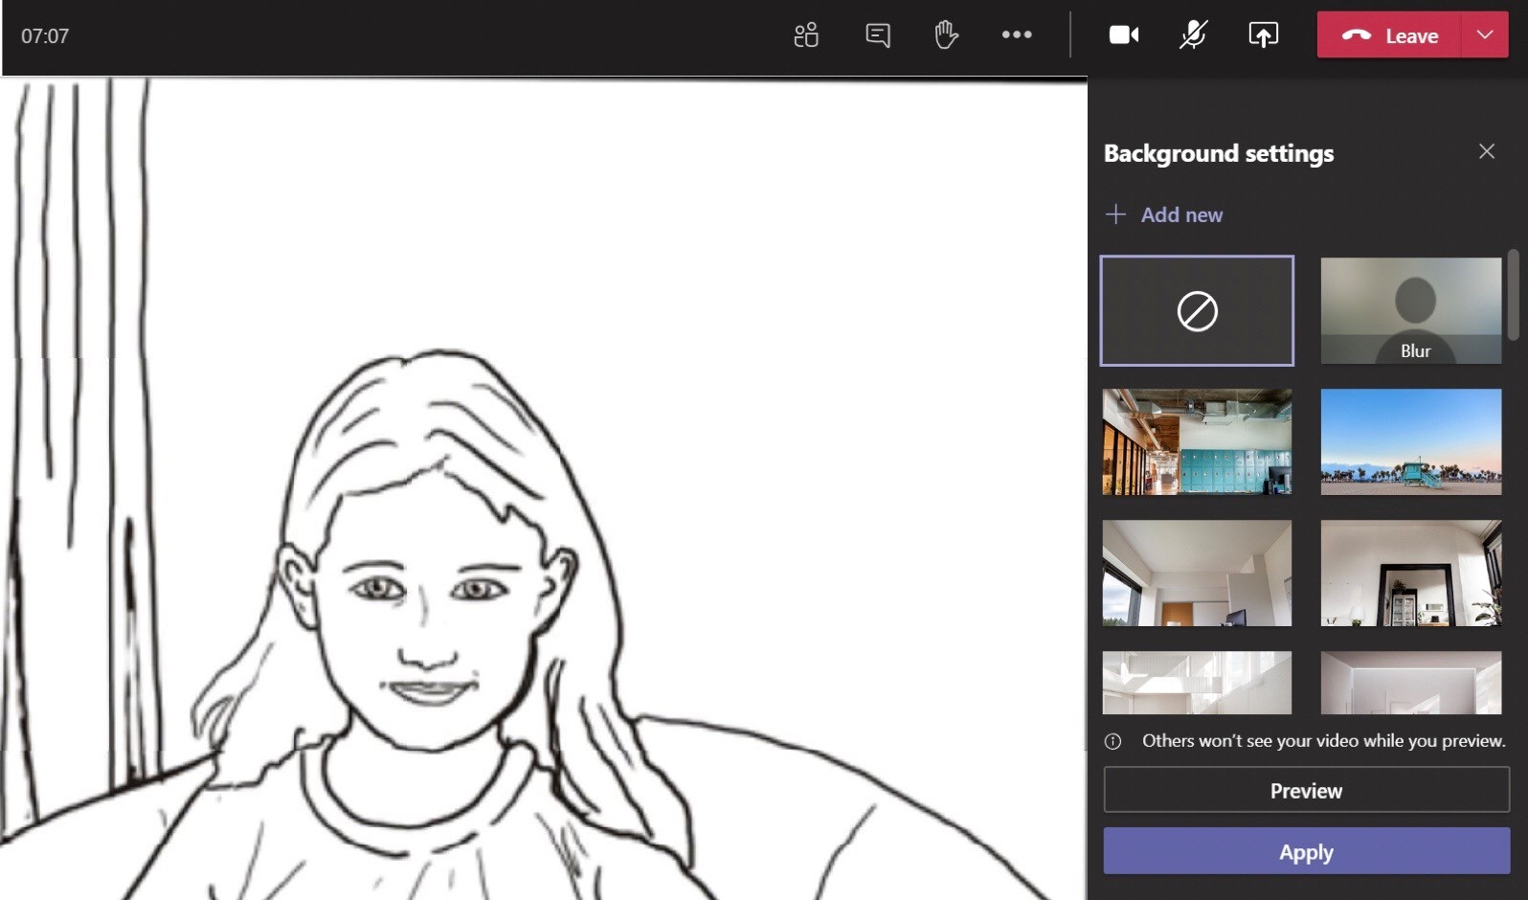

6. If you can, it is helpful for you to take an interest in your child’s lesson and stay close by so you can assist if needed.

7. To protect your own family’s privacy and that of others, we ask that participation in online meetings is kept to your child, their class and teacher.

8. If you have any concerns about the use of Microsoft Teams Meetings or the content of live lessons, you can contact your school (details here).

9. Microsoft Team Meetings can only be used by learners accessing Microsoft Teams through Glow to join video-conferencing meetings / lessons calls with members of staff.

10. Ensure you have familiarised yourself with Aberdeenshire ECS Live Online Learning Risk Assessment.

Here is a helpful guide provided by Education Scotland - MS Teams Meeting

Agreement for Remote Learning and Teaching

The teacher will:
- discuss roles and responsibilities with pupils at the outset of delivery;
- be punctual at the beginning and end of each lesson;
- set up a protocol for labelling of files for pupils;
- ensure that they keep themselves up to date with all relevant policies and procedures, including Child Protection;
- end the remote teaching experience immediately if they are feeling uncomfortable about any aspect of the experience. Follow-up with their line manager.
Pupils will have already signed ‘An Acceptable Use of ICT Agreement’ at the beginning of their school year and this agreement still stands in the virtual learning environment.
Pupil Expectations:
- only use their Glow email address for class communication;
- be punctual for all lessons;
- where required, access the files for each lesson on Glow in advance and have the materials to hand;
- make sure they have all power adaptors, laptops, screen connections ready before the lesson begins;
- submit all assignments on time in accordance to the agreed protocols;
- show respect for everyone in the online classroom;
- dress appropriately for all classes, thinking about modesty and respect for others;
- ensure the location they log in from is appropriate i.e. give consideration to background, camera angle, privacy etc. Consider making use of appropriate customised backgrounds.
- seek to contribute to the class in a positive manner and not be disruptive at any time;
- leave the Microsoft Teams Meeting if they are feeling uncomfortable;
- understand that no part of the ‘live virtual lesson’ will be recorded;
- understand and agree that no documentation stored for learning, whether it be assignments or materials shall be duplicated, copied or shared with anyone other than the pupil or school;

- Do not record or take pictures of any part of a livestream / video-conference lesson

Appendix 2: Parent/ Carer permission to deliver remote teaching into the home.

Please note that lessons are not recorded. Children’s Services requests that no attempt is made to record any online teaching by pupils or adults alike.

Pupils have already signed ‘An Acceptable Use of ICT Agreement’ at the beginning of their school year; this agreement still stands in the virtual leaning environment.

Pupil’s name

School

Class

I understand that no part of remote teaching and instrumental instruction can be recorded.

I understand and agree that no documentation stored for learning, whether it be assignments or materials shall be duplicated, can be copied or shared with anyone other than my child and his/her school.

I have read and will follow the Pupil Expectations

I give my consent to participate in livestreamed lessons, as part of online learning.

Name of Parent/Guardian

Signed Date

Name of Pupil

Signature of Pupil

