**Kemnay Primary School Bulletin**

**October 2019**

**New Head Teacher: Mr Williams**

What a wonderful school this is! I think I am the luckiest Head Teacher ever to have inherited a school with such talented and dedicated teachers, PSA’s, canteen staff, cleaners, janitor and office staff. The parents I’ve met and pupils have also been amazing. Everyone has been so polite and welcoming which has made me feel so delighted and proud to part of the Kemnay community!

**A special welcome to our new pupils:**

**In P1** – Noa. We hope you have enjoyed your time in Mrs Anderson’s class and made lots of new friends.

**The small print for P1/P2’s!** Hopefully this will not come to fruition but I think it is prudent to let you know in the small chance that we need to make changes. Our P1 class is now full and if we have another P1 join we will need to reorganise our early stages classes to accommodate everyone in adherence with the Scottish Government’s maximum class size regulations (2010). I will keep you fully informed and will try to do everything to ensure continuity and minimal disruption.

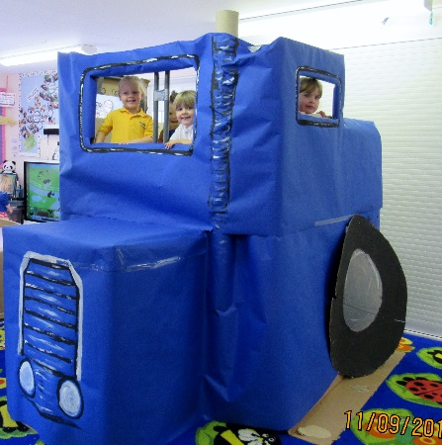**In Nursery** the class continue to have wonderful experiences led by our very talented and experienced lead practioners and team.

I was astonished to find a full tractor replica in the middle of the nursery which provided such a rich topic for discussion and learning. I am also impressed by the amazing ‘outdoor learning’ that is happening every Monday for all Nursery pupils.

Well done everyone!!

**Increased time at nursery**

Our nursery will be preparing over the coming months to expand our childcare & learning provision in preparation for implementation in August 2020. I will keep you up-to-date with the proposed changes in our offer to families.

**Staffing**

Unfortunately we are losing our Early Years Practioner, Carol-Ann Lorimer with her last day being Wednesday 9th October. We wish her all the best in her new job and I’d like to thank her for everything she has contributed to our nursery whilst she has been with us☺

The permanent post is currently [advertised](https://www.myjobscotland.gov.uk/councils/aberdeenshire-council/jobs/early-years-practitioner-169981) on myjobscotland.

We also are preparing for the Early Years Practioner, Charlotte (Charlie) Nicol’s maternity leave. We all wish Charlie all the very best with this upcoming experience. This is due to commence on Wednesday 4th December. The temporary post will be advertised shortly.

**Water Bottles**

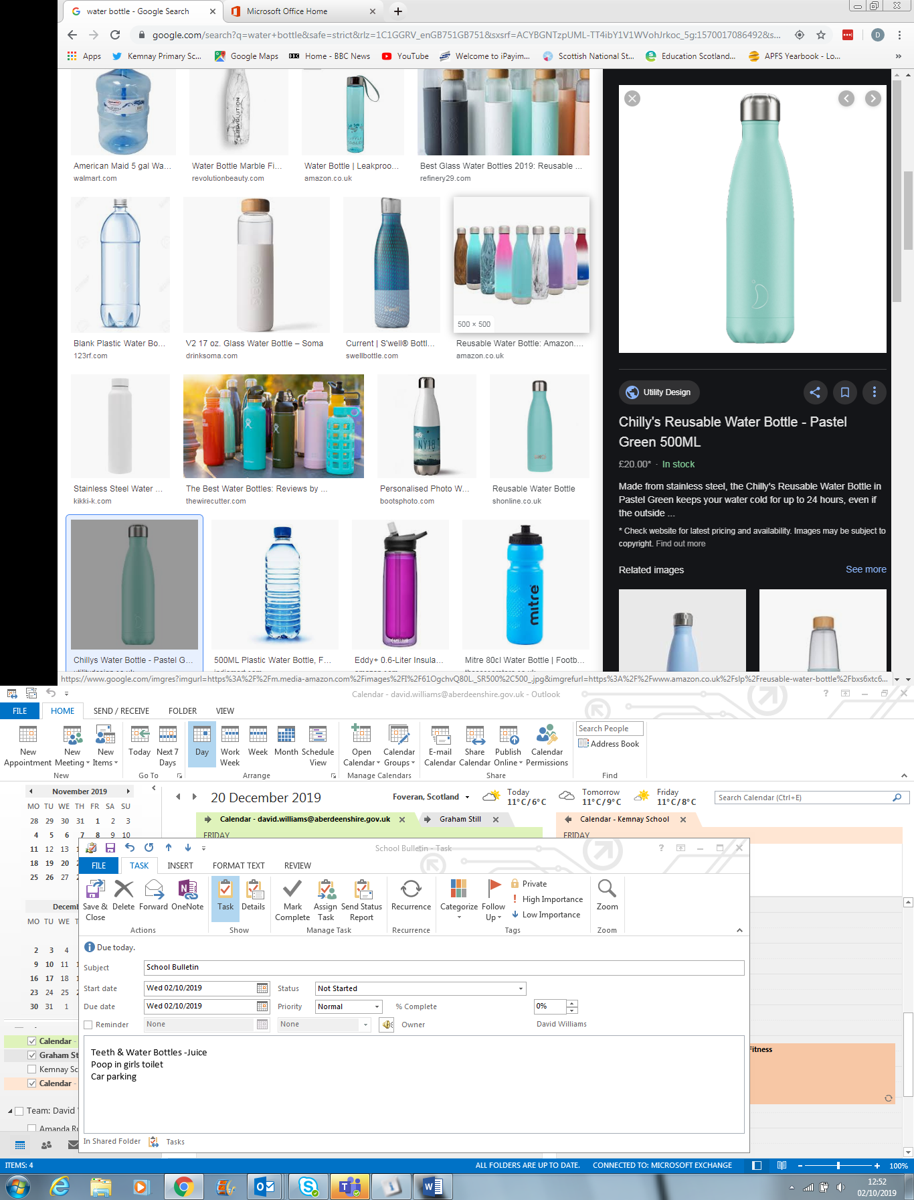The metal water bottle/canister/flask is all the rage at the moment but unfortunately the containers that don’t have a plastic rim are dangerous and banned from use by our pupils. We have had an incident that chipped a tooth unnecessarily due to the metal edge/rim. Please refrain from providing a bottle without a plastic lid.

As a reminder, the contents should only be water. Diluted juice, when spilt, can be very sticky and cause stains. We recommend, if your child would like some flavour that a slice of fruit is put in the water bottle.

**Pupil Achievements**

Emily in P1 did her grading in Soo Yang Do and achieved her **yellow belt**☺

Brooke in P2 has achieved **level E** at Pony Club☺

The very modest Casey in P6/**7**C has been excelling in her gymnastics as part of the Garioch Gymnastics Club! : <https://www.inverurieherald.co.uk/sport/other-sport/garioch-glitter-girls-in-action-at-liverpool-open-competition-1-5006625>

**Car Park**

**The staff car park is for staff cars only between 8am and 4pm. Pupils should not be in the staff car park unless this is out-with 8am and 4pm where the children are accompanied by a responsible adult.**

**School Improvement Plans**

Reporting – [SeeSaw](p%3e%3ca%20href=%22https:/web.seesaw.me?wvideo=r9j1hrzl65%22%3e%3cimg%20src=%22https://embedwistia-a.akamaihd.net/deliveries/f14c1f4bae86f35dc47ad4ed84078e7e.jpg?image_play_button_size=2x&amp;image_crop_resized=960x540&amp;image_play_button=1&amp;image_play_button_color=54bbffe0%22%20width=%22400%22%20height=%22225%22%20style=%22width:%20400px;%20height:%20225px;%22%3e%3c/a%3e%3c/p%3e%3cp%3e%3ca%20href=%22https://web.seesaw.me?wvideo=r9j1hrzl65%22%3eSeesaw%3c/a%3e%3c/p) app is being introduced this school year as our means for us to report your child’s progress throughout the year. We will still have a paper, attainment report towards the end of the curricular year.

We are hosting a launch evening to explain how it works on Tuesday 26th November from 5-7pm. Codes will be released beforehand so you can access your child’s page and see how it works. Any questions can be answered in this workshop evening.

Other tables on a variety of topics will also be set-up including spelling, homework, Rights Respecting Schools Award, Sum-dog, Digital Schools, etc. for your information.

Pupil will be starting to populate their pages, so if you haven’t already done so please return the permission slip on the attached letter to allow your child to post videos, photos of their own progress. Don’t worry if you do not want photos/videos to be taken we will be able to record copies of their work for you to view.

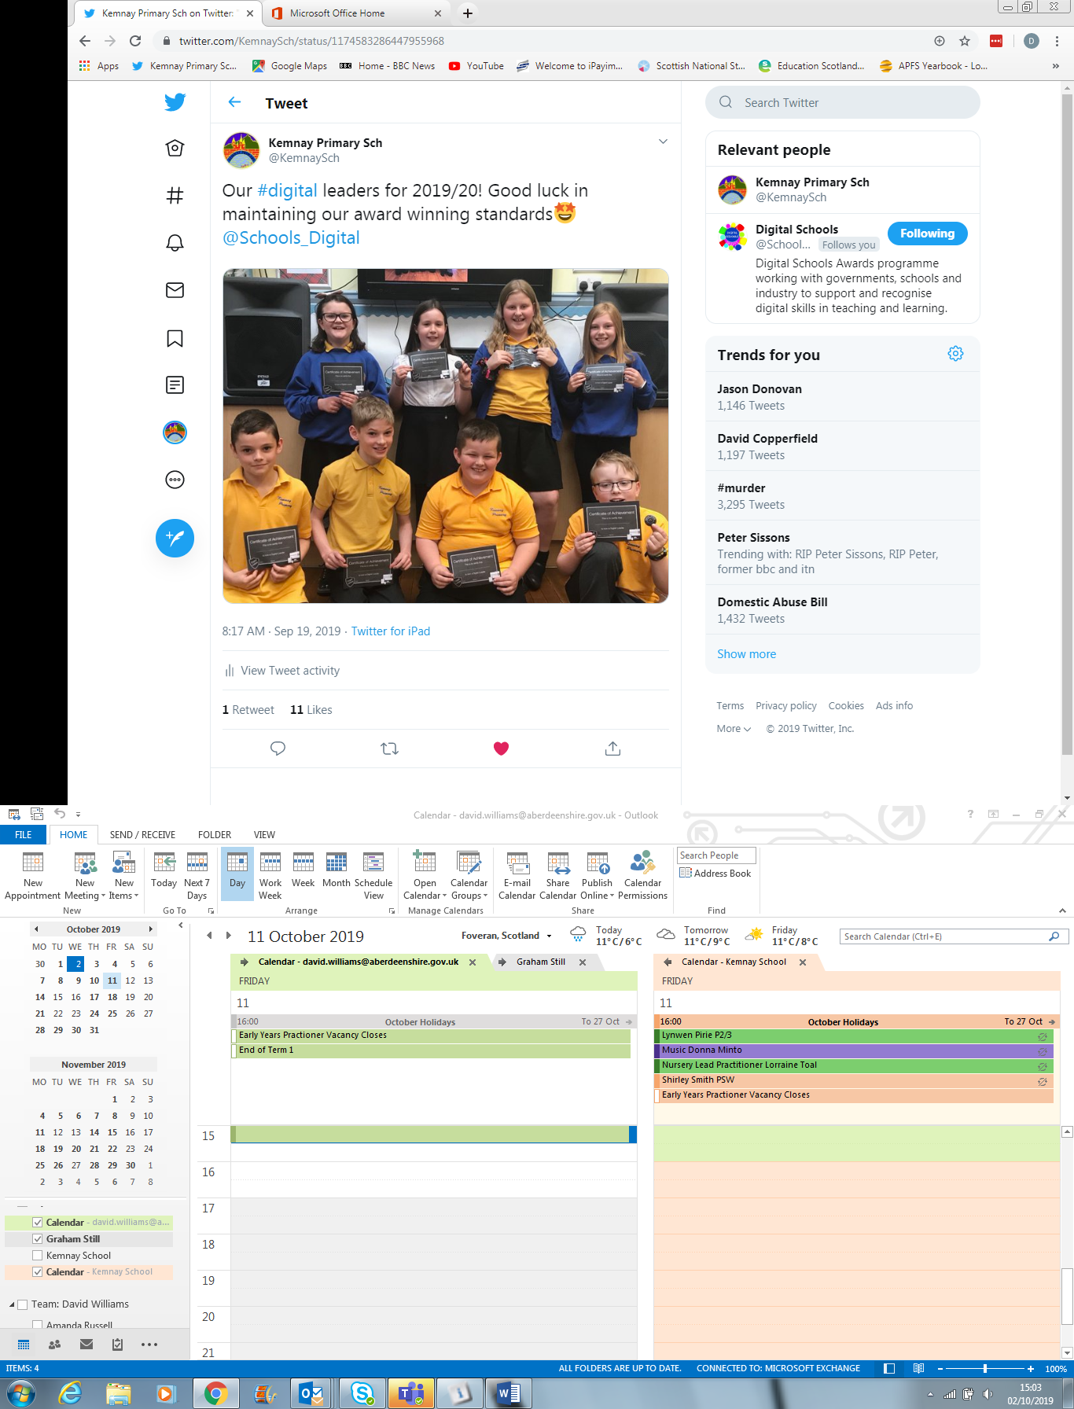

**Twitter**

The school often posts achievements, information, community adverts, positive newsworthy events, support local/national/international causes that align with KPS values on our school twitter account: [@KemnaySch](https://twitter.com/KemnaySch)

The twitter account can be especially useful when your child is on a school trip, so you can get a flavour of what they are doing and estimated time of arrival if it is after normal school closure time (HMT Panto, Ski-trip, Abernethy).

It is also particularly useful on potential days of snow closure, delayed opening/early closure (adverse weather/heating issues) and any power cuts.

**Easy Fund Raising**

If you do a lot of; shopping through Amazon, booking a holiday, organising car hire, renewing insurance or ordering books to read, the school can benefit from these purchases from 0.25% - 5% of the amount spent!

Just create an account on [easyfundraising.org.uk](https://www.easyfundraising.org.uk/causes/kemnaypspta/), then support a cause, hopefully you’ll choose Kemnaypspta. You can then access just about any retailer from their site. They will redirect you and we’ll start reaping the rewards.

Please pass on to all relatives or friends that spend an insatiable amount on the internet!

**Crossing Patroller**

Being a crossing patroller can be a very rewarding job for many, many reasons. A great job for being part of the community, exercise, routine, keeping children safe and almost always being universally loved by everyone!! If you know anyone that would like to be part of our team please [apply](https://www.myjobscotland.gov.uk/councils/aberdeenshire-council/jobs/school-crossing-patroller-170279) on myjobscotland. For more details, contact Ian Allan – Supervisory Janitor at Kemnay Academy on 01467 643535

Yours sincerely,

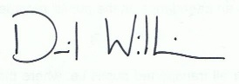

David Williams

Head Teacher

**Diary Dates**

Please also find attached term calendar. Holiday dates were sent home at the end of last term. Please contact the office if you require another copy.

Christmas related event schedules will be released early/mid November.

Fri 4th Oct: Quiz Night @Bennachie Lodge

Mon 7th Oct: Kemnay School Football Team Training 3:15-4:30pm

Tue 8th Oct: Abernethy Information Evening @6.30pm in P6/7R classroom

Wed 9th/Thurs. 10th Oct: Parents Evening

Fri 11th Oct: In-Service Day: **School Closed** for pupils

Mon 28th Oct: First Day of Term 2

Wed 30th Oct: Kemnay School Parent Group (KSPG) meeting 7pm

Mon 11th Nov: Flu Vaccinations Day

Mon 18th Nov: In-Service Day: **School Closed** for pupils

Tue 19th Nov: In-Service Day: **School Closed** for pupils

W/B 25th Nov: School Bulletin with all Christmas performance/celebrations included.

Tue 26th Nov: School Information Event (SeeSaw Launch) 5-7pm in School gym halls/P5 classroom

Sat 30th Nov: Christmas Fair 11-1.30pm

Tue 3rd Dec: Cinderella Pantomime @HMT 1.30-5.30pm approx.

Fri 20th Dec: Last day of Term 2